Historic Gila Habitat
Pima-Maricopa Irrigation Project Education Initiative

Restoring water to ensure the
continuity of the Akimel O’otham
and Pee Posh tradition of agriculture

Re

Part 3

The physical environment of the Gila River Indian Community has been significantly changed over the past two centuries. The historic habitat of Akimel O’otham Country included four distinct environments. There was the Gila River and its tributaries, which provided a source of water year-around. Then there were large riparian woodlands, dominated by cottonwood and willow trees. In many areas of the Community there were mesquite bosques, providing an abundant supply of wood and food for the people. And, finally, there were large grasslands, providing year-around supplies of forage for the large herds of animals maintained by the Akimel O’otham.

The Gila River and its Tributaries
The Gila River and many of its tributaries once flowed year-around. At times, the Gila River disappeared below the riverbed, especially during times of low water flow. Within present Community lands, the river often dipped below the land surface only to re-emerge near the historic Akimel O’otham village of Sudacson. As late as the early 1900s, the United States Geological Survey identified eight islands in the Gila River between Pima Butte and the east end of the reservation. Some of these islands were one to two miles in length.
The Gila River flooded each year, depositing nutrient-rich sediment along the bottomlands. “The river rose twice annually, flooding the islands and the lower terraces, after the spring snowmelt in the headwaters and again during the midsummer monsoons. Flood irrigation of these lowlands was the major, if not exclusive, agricultural method” of farming these lands. Before the river system was depleted, the Gila was, on average, about 40 yards wide and two feet deep. Along the easternmost Akimel O’otham villages, the river was “much contracted, with steep banks fifteen feet high” and not more than “nine inches” deep.
Fish were an important source of food for the people. The late Joseph Giff and Sylvester Matthias, from Komatke, recalled nearly a dozen species of fish that once called the river home. Dozens of species of birds lived along the Gila River, as did scores of river plants. A number of sloughs (cienegas or low-lying wet areas) existed along the river. The largest was on the Santa Cruz River between Maricopa Wells and Santa Cruz Village. Akimel O’otham elder Matthias remembered many small creeks along the Estrella Mountains that fed the river. Along with mesquite bosques, there were meadows of dock, salt grass and other native grasses. Even the area west of Bapchule was thick with vegetation, giving rise to the name “Louisiana” because it resembled a bayou.
The Gila was also once teeming with beaver. By the 1830s they were trapped into near extinction, causing significant environmental consequences. By constructing dams, beaver helped contain the rapid rain runoff in the Gila and its tributaries. When the beaver disappeared from the river system, waterfowl suffered as well. The Gila was already a fragile environment. Any change in the river ecosystem impacted the river itself, including the flora and fauna it supported.
Riparian Woodlands
Draping the river was a thick canopy of cottonwoods and willows. In 1858, John Reid passed through Akimel O’otham and Pee Posh Country and noted the river was “told a long way off by the green cottonwoods which fringe its banks.” The woodlands along the river were once so thick that they obscured the view of the river. East of the “Pima villages” the river channel was so narrow and thickly populated with cottonwoods that the trees lining either bank met in the middle and formed a canopy over the river.
US-Mexico boundary line surveyor John Bartlett described a “thick underbrush of willows” that he had to push through before he could reach the river. Once at the river he found “many fine large cottonwood trees, beneath which we stopped, and which afforded us a good shade from the scorching rays of the sun.” In places, thick mesquite bosques abutted the riparian woodlands, giving the river a very different look than it has today.
Mesquite Bosques
Large bosques of Velvet Mesquite were found throughout the land on low alluvial plains along the Gila, Salt and Santa Cruz rivers. The largest bosque stretched from the confluence of the Gila and Salt rivers south and east along the Gila and Santa Cruz rivers in the southern part of present-day District Six to Pima Butte. It is here that the famous “New York Thicket” is found. This bosque was more than “six miles in diameter.” While some of this original bosque still stands, large portions no longer exist.
Another nearby bosque extended on the north side of the Gila River between present-day Maricopa Road and Gila Crossing. On the eastern side of this bosque the only evidence that still remains are large stumps that protrude from the ground. Other bosques were located in the flats between the Sacaton Mountains and Blackwater (along McClellan Wash), and in the area near Goodyear in the Queen Creek drainage area.
Mesquite bosques were important to the Akimel O’otham and Pee Posh; indeed the mesquite was the staple of life. Mesquite pods, or beans, were used as source of food. The trees themselves were an important source of heating and cooking fuel. They were also used in the construction of homes, ramadas and storage sheds. The bosques were not typically solid stands of trees. In the case of the “New York Thicket,” there were several acres of thick mesquite mixed in with large open areas. Stands of mesquite growing along mountain washes typically connected the thickets. Bosques east of present-day Sacaton were “thickly covered with mezquit-trees from twelve to twenty feet in height.” Even the lands around Casa Grande Ruins were once thick with mesquite. Samuel Cozzens, writing in 1859, observed “dense groves of mesquite and cottonwoods” growing along the banks of the river. Other areas were plains “overgrown with mesquite.” These mesquite trees were growing on ancient Huhugam fields that had long been abandoned.
Grasslands
Not all of the land in Akimel O’otham and Pee Posh Country was clothed in mesquite or farmed. Much of the land included localized grasses. Several known areas of grass have been identified, one near Maricopa Wells and the other southeast of the Sacaton Mountains. Another grassland existed along the Queen Creek drainage near present-day Goodyear. The size of these grasslands was large and they have been described as “abundant pasturage for several hundred to more than a thousand head of livestock for a period of days, at least.”
The late Joseph Giff described one of these areas upstream from Santa Cruz. “Up at the other end was a village called Nakshel Vavhia (scorpion well), where a few families lived…. Grass was high all the time—lots of feed.” The site was also known as Yaanos. Sylvester Matthias recalled that, while the land consists of mesquite thickets today, it “used to be just open place” with several washes coming together. “It’s a long stretch [with] creeks [and] seepage water…. At Hannamkam Wecho (beneath a place that has chollas), [there is] a little butte there, [just] west of Casa Grande, right under there somewhere is good grazing land.” These grasslands were located near the southern end of the Estrella Mountains, in an area often mentioned by early travelers passing through. Matthias also recalled a place called Toota Mudadkam. “It’s the name for a grass and the name for [a] place, now [called] Chandler…. Where Chandler is now—Queen Creek [used to] flood all that area.”
There are several reasons why grasslands once occupied so large a portion of the land. While it is unusual that grasslands are found at elevations between 1,000 and 1,200 feet, the reason may be physical. The grasses grew in areas with a fine, deep soil and a high water table. In the Maricopa Wells area, the water table was high because the Vekol, Santa Rosa and Greene’s washes all converged with the Santa Cruz River. In the grasslands southeast of the Sacaton Mountains, McClellan Wash provided a source of water. “Before the advent of grazing, the relatively low watersheds of these washes were in much better condition to supply underground water, if not surface, most of the year.” A second reason for the abundance of grasslands is due to Akimel O’otham uses of fire, which prevented the growth of mesquite, acacias and other trees that competed with grasses. At any rate, “the once famous grassy plains that made the Pima villages a haven of rest for cavalry and wagon-train stock are now barren.”
Akimel O’otham and Pee Posh Country was at one time a diverse area of flowing streams, riparian woodlands, mesquite bosques and grasslands. This environment provided for the needs of the Akimel O’otham and Pee Posh. Altering this fragile environment could only lead to significant cultural change among the people.

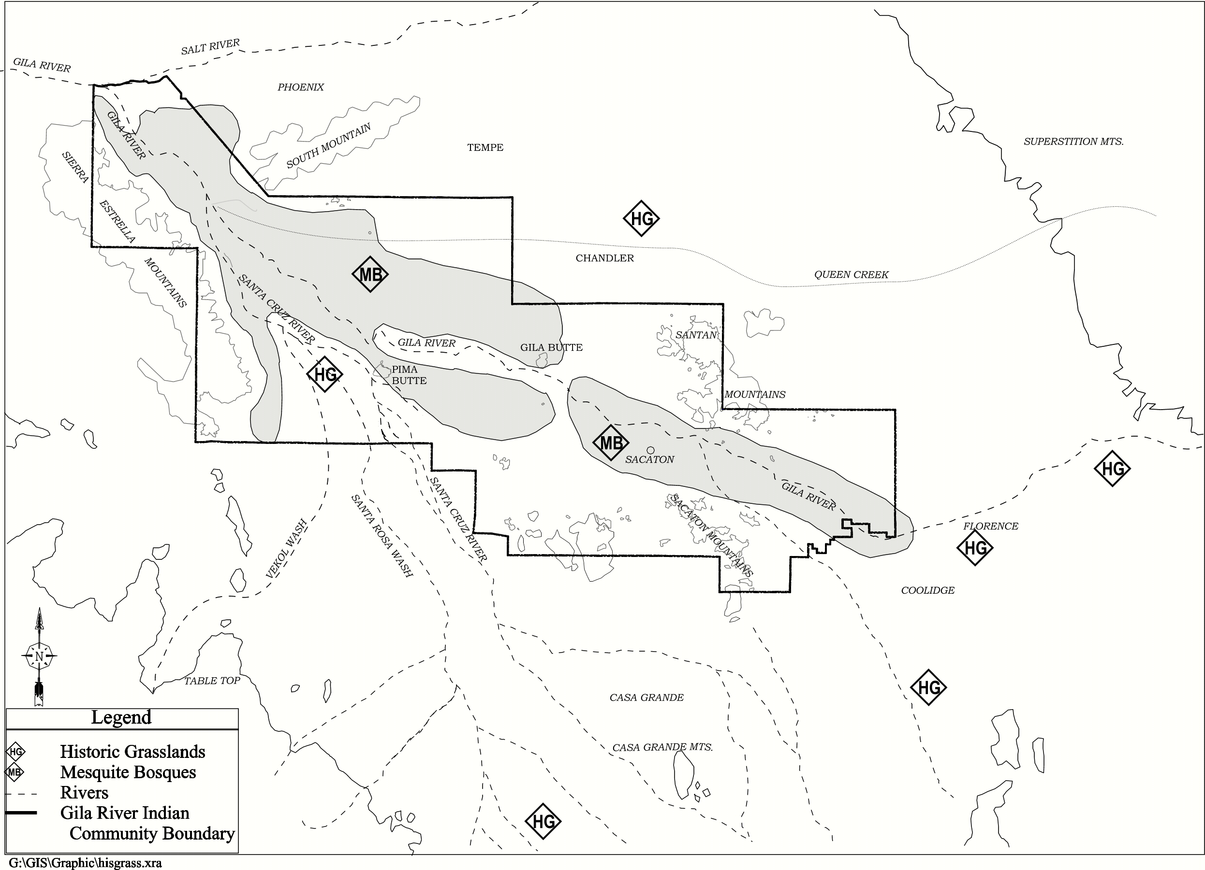

Teacher Plan for “Historic Gila Habitat”

Objectives

Students will be able to:

- Compare historic habitat along the Gila River with that of the present day.

- Describe the traditional habitat of the Gila River Valley.

Terms to know and understand

- Bayou
- Tributaries
- Terraces
- Ecosystem
- Bosques

Critical Thinking:

- Imagine the Gila River Valley with an abundance of water, mesquite, riparian woodlands and native grasses. How might this habitat affect you? How might it impact wildlife?

- How would your life be different today if the historic Gila habitat remained in place?

Activities:

- Have students interview tribal elders about areas such as “New York Thicket” and “Louisiana.” How did these places receive these names? Why? If possible, take a field trip to these areas. Have students draw what they see today.

- Have students research the type of beaver that once called the Gila River home. What other impacts resulted from the destruction of the beaver? Have students research the importance of beaver dams. How did a beaver habitat impact the river system?

- In Part 2 of this series, students looked at how the flora and fauna of the Community were impacted by the altering of the river system. Have students research native grasses that once grew in the Gila River Valley. Can these be restored? Should they? Take a field trip to the historic Queen Creek drainage area. How has the environment been impacted with the loss of this creek?

About P-MIP

The Pima-Maricopa Irrigation Project is authorized by the Gila River Indian Community to construct all irrigation systems for the Community. When fully completed, P-MIP will provide irrigation for 146,330 acres of farmland. P-MIP is dedicated to three long-range goals:
- Restoring the use of water to the Akimel O’otham and Pee Posh
- Putting Akimel O’otham and Pee Posh rights to the use of water to beneficial use
- Demonstrating and exercising sound management to ensure continuity of the Community’s traditional economy of agriculture

